

**COLLEGE OF COMPUTING AND INFORMATION SCIENCES**

**DEPARTMENT OF NETWORKS**

**BACHELOR OF SCIENCE IN SOFTWARE ENGINEERING (YEAR 2) RECESS TERM 2 (BSE 2301)**

**SOFTWARE DESIGN DOCUMENT FOR:**

**MOBILE APP STATISTICS PROJECT**

**PROJECT MEMBERS (GROUP 14)**

|  |  |  |  |
| --- | --- | --- | --- |
| **NAME** | **REGISTRATION NUMBER** | **STUDENT NUMBER** | **SIGNATURE** |
| WAMOZO COSMAS | 16/U/12299/PS | 216007584 |  |
| MUGARURA ALLAN | 16/U/7237/PS | 216008460 |  |
| BUSUULWA MARTIN | 16/U/4479/PS | 216004416 |  |
| NICHOLAS HENRY SSEBIRUMBI | 16/U/11512/EVE | 216011052 |  |

**PROJECT LEADER**

NICHOLAS HENRY SSEBIRUMBI

**SUPERVISOR**​

MBABAZI ISAAC

**19TH​ JULY, 2018**

**Table of contents**

**Table of contents** 2

1 Introduction. 4

1.1 Purpose. 4

1.2 Scope 4

1.2.1 Goal. 4

1.2.2 Objective. 4

1.3 Definitions, Acronyms and Abbreviations. 5

1.4 Overview. 5

1.4.1 System overview. 5

1.4.2 System architecture. 5

1.4.3 Component description. 6

1.4.4 Human interface design. 6

1.4.5 Requirements Traceability Matrix. 6

2 System overview 6

3 SYSTEM ARCHITECTURE 7

3.1 Architectural Design. 7

3.2 design rationale 8

3.3 decomposition description. 8

4 Component design 10

5 Human interface design 11

5.1 overview of the user interface 11

5.2 Screen images 11

5.3 Screen objects and actions 13

6 Requirements matrix 14

7 Reference 15

**Tale of figures**

Figure 1: Context diagram of the System architecture. 6

Figure 2: System architecture 7

Figure 3: Data flow diagram 9

Figure 4: Home tab interface 11

Figure 5: Import dataset interface 11

Figure 6: Visualization interface 12

Figure 7: Summary interface 12

Figure 8: Sentimental interface 13

Figure 9: Help interface 13

# Introduction.

## Purpose.

The purpose of the software design document is to provide the overall description and track the necessary information required to effectively define architecture and system design in order to give the development team guidance on the architecture of the Mobile App Statistics system to be developed.

The expected audience of this document is the department of Networks of the College of Computing and Information Sciences (**COCIS**) at Makerere University as well as the developers and anyone who intends to develop on this project.

## Scope

The **Mobile App Statistics** is a data system that analyzes app details from the **App Store** and generates insights which are intended to help developers get more people to download their applications and optimistically increase the user ratings of their apps. Users of this system can use it to collect analysis on how different application details affect the user ratings of an application on the store and also app details can be visualized giving a clear understanding of the data to the users.

### Goal.

To help developers get more people to download their applications.

### Objective.

1. Collecting analysis on how different application details affect the user ratings of an application on the store.
2. To compare the statistics of different app groups, so that the app developer may know which app group the users are most interested in.

## Definitions, Acronyms and Abbreviations.

|  |  |
| --- | --- |
| Word/Abbreviation | Meaning |
| RAM | Random Access Memory. |
| IEEE | Institute of Electrical and Electronic Engineers. |
| CPU | Central Processing Unit. |
| COCIS | College of Computing and Information Sciences. |
| Context diagram | A representation of the relationship between the system and its external entities. |
| Data flow diagram | A graphical representation of the flow of data through an information system , modeling it’s process aspects |
| Architecture | High level structure of the software system. |

## Overview.

**The remainder of this SDD is six chapters with other subsections so as to give a clear understanding of the project. These chapters include the following;**

### System overview.

**This section contains the general functions, operations and capabilities of the system to be developed and an understanding of how the users interact with the system to achieve their goals.**

### System architecture.

**This shows the type of architecture design considered in the designing of the system and the modular program structure with a description of how the modules relate to achieve a complete functionality of the system.**

**The main purpose is to a general understanding of how and why the system will be decomposed, and how the individual parts will work together.**

**The design rational that expresses reasons why the architectural design used was considered and why other types weren’t considered.**

### Component description.

**This section provides a summary of the algorithm for each function or component in form of a pseudo code.**

### Human interface design.

**This section describes the system functionality from the user’s perspective. It explains how the user interacts with the system to complete all the expected features and how the system will give feedback to the user.**

**Screen images to show the user interface, screen objects and actions are also in this section.**

### Requirements Traceability Matrix.

This section shows a mapping of each system requirement to the actual system component that function to achieve the requirement.

# System overview

The Mobile App Statistic project is for analyzing the data set uploaded by the user that contains Apple iOS mobile application details. The system will come up with a detailed analysis of the dataset showing how the app details affect the user rating and visualized comparisons of the data. These visuals will then be provided to the users of the system and the marketing staff as outputs.

The general overview of the system is shown by the context diagram below.

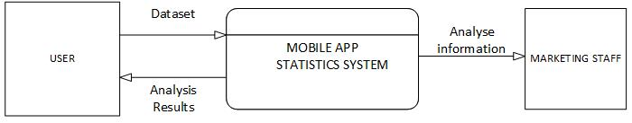

Figure 1: Context diagram of the System.

# SYSTEM ARCHITECTURE

## Architectural Design.

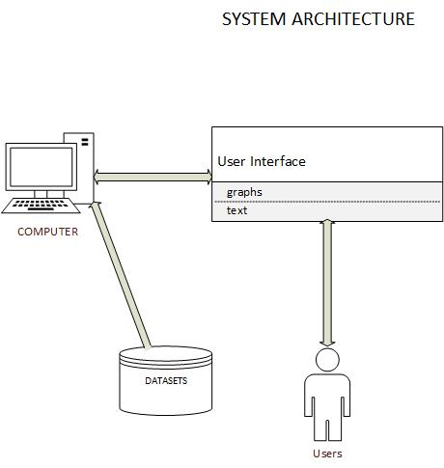

Figure 2: System architecture

**SYSTEM ARCHITECTURE DESCRIPTION**

The system will use a two tier architecture with the presentation and application layers on the same computer where the interface and the system itself resides. The Dataset will be regarded as the Data store on the other hand.

Users

These are the different app developers who will be interacting with the system through the graphical user interface on the computer monitor

User Interface

The user interface will be helpful to the user by displaying all the analysis done by the system such as visualized diagrams. It will also display help options that will guide the user on how to use the system

Computer

The computer is the machine that will be capable of hosting and running the system with all its functions and also display the user interface. The computer will also store the datasets which the system will import for analysis to start

Datasets

The data store considered in this case will be the datasets that will be imported in to the system for analysis.

## design rationale

This architecture was chosen because of the reasons below

1. Communication between the dataset and the system is faster due to direct communication
2. There is no need for database management
3. There is no need for Internet connection hence limited costs for the user

## decomposition description.

This section shows a further break down of the system than in the context diagram already shown. The client inputs the app details in the dataset in form of a csv file. The system then uses these details to create a summary out of it and also to create visuals. the system then displays this information to the users of the system.



Figure 3: Data flow diagram

# Component design

The system features here are broken down in form of summarized algorithms and written in pseudo code.

**Import data set**

Start

Choose a csv file

Import file

Exit

**Visualize data**

Start

Select desired columns

Create desired graphs

Exit

**Create summary**

Start

Select desired columns

Generate summary

Display summary

Exit

**Get help**

Start

Choose the desired category

Display the category description information

Exit

**Perform sentiment**

Start

Click either sentiment or polarity

Display sentimental motions or polarity

Exit

# Human interface design

## overview of the user interface

The user interface enables user interaction with the Mobile App Statistics system.

## Screen images

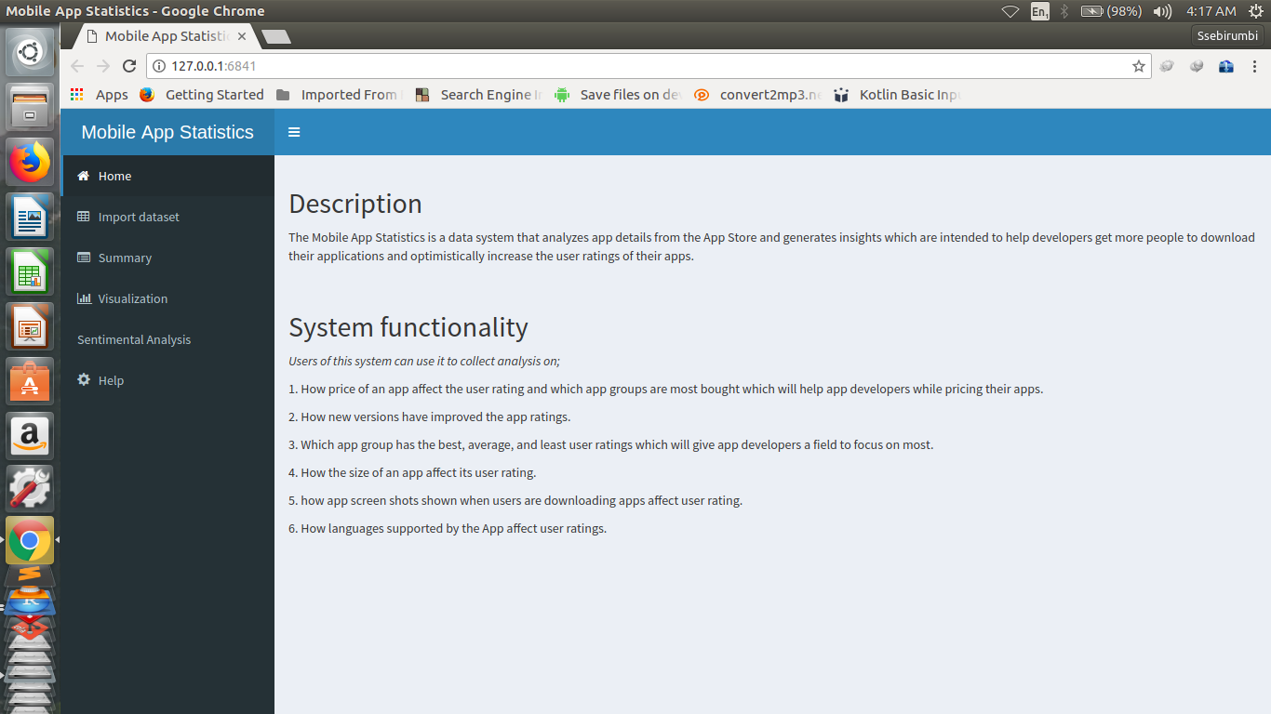

Figure 4: Home tab interface

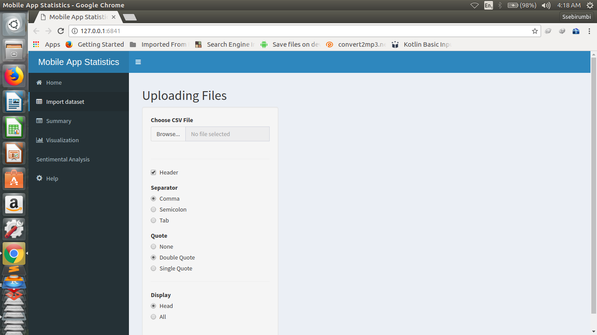

Figure 5: Import dataset interface

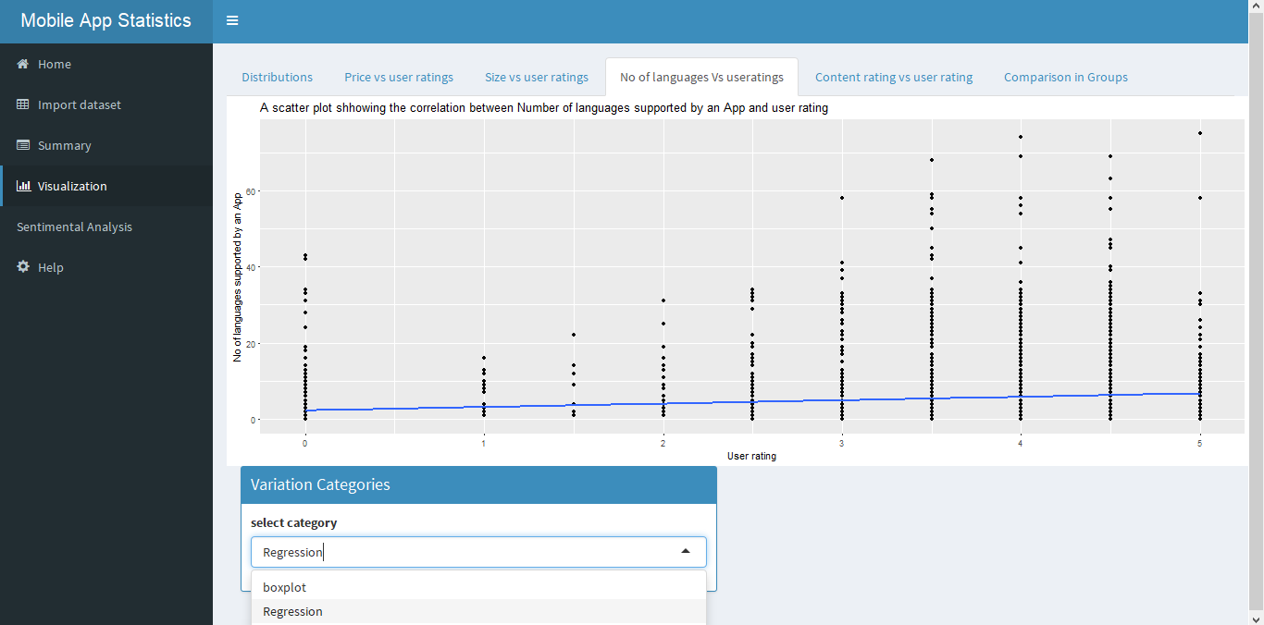

Figure 6: Visualization interface

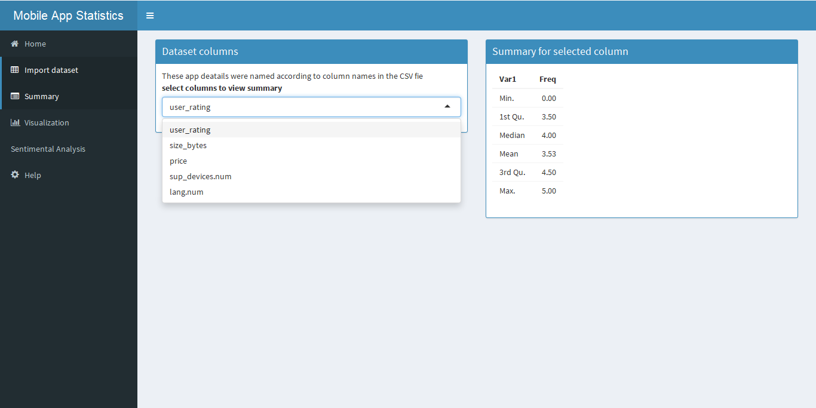

Figure 7: Summary interface

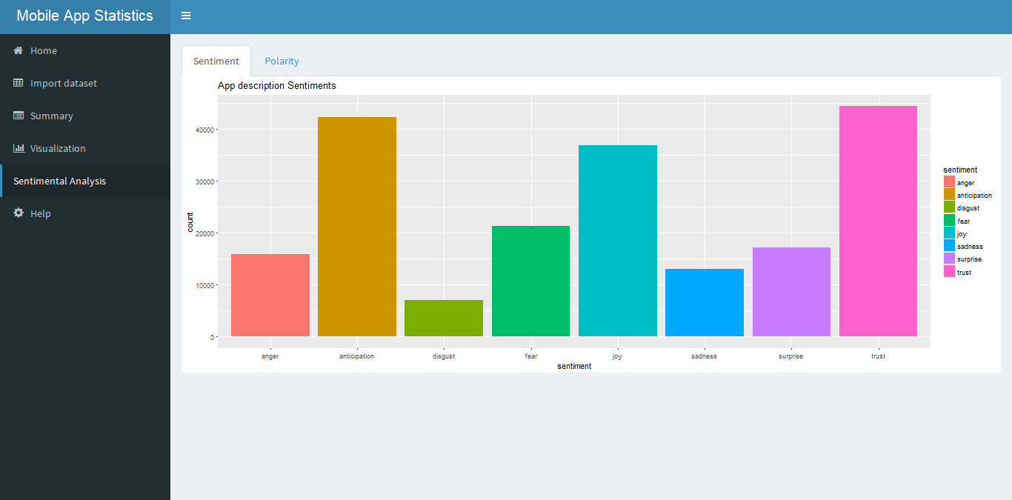

Figure 8: Sentimental interface

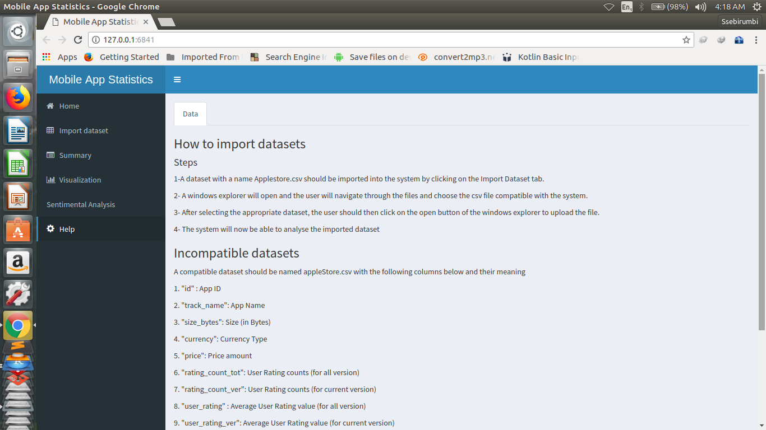

Figure 9: Help interface

## Screen objects and actions

Figure 4

When a user clicks on the home tab, a brief description of the system will be displayed as in *Figure 4.*

Figure 5

When a user clicks on choose a file to upload, a window will be displayed for the user to choose the desired file. After choosing the file, then, the system will upload the dataset and display it.

Figure 6

When a user clicks the visualization tab, a screen with different tab will be displayed as shown in *Figure 6*. Depending on which tab is selected, a visual will be displayed for example in *Figure 6,* the box plot is displayed when a user clicks on the Box plot tab.

Figure 7

When a user clicks on the summary tab, a screen in *figure 7* will be displayed. The user clicks on the drop down menu to choose which column summary is to be displayed.

Figure 8

When the user clicks on the sentimental tab, a screen in *figure 8* will be displayed. The user clicks on either polarity or sentiments.

Figure 9

When the user clicks on the help tab, a screen with steps or guide lines on how to navigate or use the system will be displayed as shown in *figure 9.*

# Requirements matrix

|  |  |
| --- | --- |
| **System requirement** | **System component** |
| Import data set | Import csv file tab |
| Visualize data | Graphs feature |
| Display summary | Summary tab |
| Display help information | Help tab. |
| Display sentiments and polarity | Sentimental analysis tab |

# Reference

[1] Apple Store Optimization (ASO):

<https://www.apptamin.com/blog/app-store-optimization-app-ratings/>

[2] Wikipedia

https://en.m.wikipedia.org>wiki